5.0 FLOW CHART

SYSTEM ARCHITECTURE

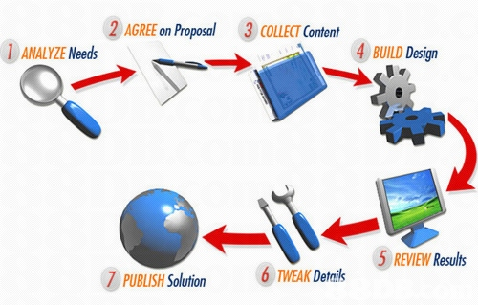

FUNCTIONAL MODEL
Process flow chart
A flowchart is defined as a pictorial representation describing a process being studied or even used to plan stages of a project. Flow charts tend to provide people with a common language.
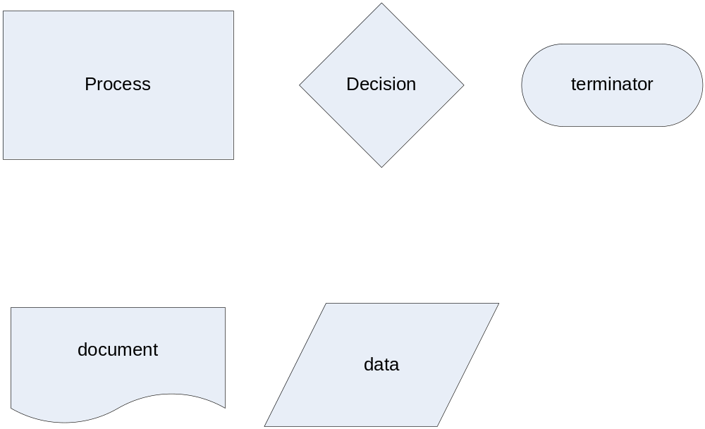

Fig 5.1 Notations of Flow Chart

Process flow chart for system is as follows:

